**PROJECT MANAGEMENT PLAN**

**TRANSPORT NETWORK VEHICLE SYSTEM  
(ADMINISTRATIVE)**

**TRAILAD.CO**

**MV Campus**

**Quezon City, Philippines, 1118**

**9/25/2025**

Introduction 1

Project Management Approach 2

Project Scope 3

Milestone List 4

Schedule Baseline and Work Breakdown Structure 5

Change Management Plan 6

Communications Management Plan 7

Cost Management Plan 8

Procurement Management Plan 9

Project Scope Management Plan 10

Schedule Management Plan 11

Quality Management Plan 12

Risk Management Plan 13

Risk Register 14

Staffing Management Plan 15

Resource Calendar 16

Cost Baseline 17

Quality Baseline 18

Sponsor Acceptance 19

1. **INTRODUCTION**

**-** Our project, the TNVS administrative system, was developed to help improve how administrative work is done. Since we are focusing on the administrative side of TNVS (Transport Network Vehicle System) our goal is to create a system that can make managing records, documents and reservations easier and more organized.

In this project, we wanted to experience a work of an administrative team for the company. We learned how to manage information, handle requests and communicate properly within a system. The project also helps us understand how different functions can work from processing reports to keeping important file safe and accessible.

1. **PROJECT MANAGEMENT APPROACH**

**-** This project is dividing our responsibilities with different approaches. Each of us had a specific role, but helped each other.

The project leader guided the group, set deadline and kept everyone on track, the programming team handled the coding and system development while the documentation team ensures that every report and requirement was complete and updated. From Planning to Designing, Developing, Testing and Finalizing the system and documents through the help of communication making the project work efficiently without issues.

1. **PROJECT SCOPE**

**-** The scope of our company the TrailAd.Co is to ensure that the administrative work can be handled by our organization, from planning to design and development the admnistrative is working really well. Since being an administrative is a hard part of the system from room reservations, documents handling, to legal acquirements is well met, by having a scope for the project we can manage the development of the system as well as the functions that are needed for processes.

1. **MILESTONE LIST**

**-** This section lists the major milestones for the TNVS Project. Milestones are significant points or events in the project timeline that marks the completion of key deliverables.

The following are the major project milestones:

| **Milestone** | **Description** | **Target Date** | **Responsible Party** |
| --- | --- | --- | --- |
| Project Initiation | Approval of TNVS Research Project business case and allocation of resources. | July 11, 2025 | Project Sponsor, PMO |
| Requirements Gathering | Collection of technical, legal, and operational requirements for TNVS. | July 18, 2025 | Research & Analysis Team |
| System Design & Planning | Development of high-level architecture, process flows, and design documents. | Aug 1, 2025 | Technical Team, PMO |
| Prototype Development | Creation of a functional TNVS prototype for testing core features. | Sep 23, 2025 | Development Team |

|  |  |  |  |
| --- | --- | --- | --- |
| Pilot Testing & Evaluation | Conduct small-scale TNVS pilot in a selected area; gather feedback and results. | Oct 10, 2025 | QA Team, Operations Team |
| Final Review & Approval | Present pilot findings, adjust system, and secure final go-live approval. | Oct 30, 2025 | Project Steering Committee |
| Full System Deployment | Launch of TNVS across target operational areas. | Nov 30, 2025 | Operations & IT Teams |
| Project Closure | Completion of documentation, handover, and final project sign-off. | Dec 15, 2025 | Project Manager, PMO |

1. **SCHEDULE BASELINE AND WORK BREAKDOWN STRUCTURE**

**-** In our TNVS Administrative System project, we organized our tasks using a work breakdown structure (WBS) to make the workload clearer and easier to manage. The WBS helped us divide the entire project into smaller, more specific tasks so that everyone in the team could focus on their part.

Each part of the WBS represents a step in completing the project. For example, we seperated it into planning, designing, development. This allowed us to track our progress and know what needed to be done.

This is an overview of the Work Breakdown Structure (WBS):

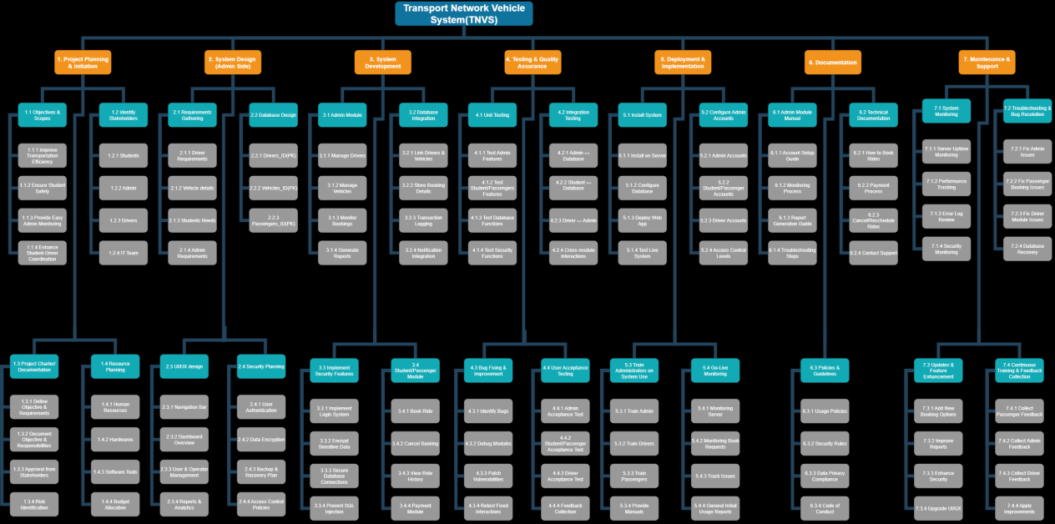

1. **CHANGE MANAGEMENT PLAN**

**-** In Change Management Plan explains how our team handles any changes or modifications that may occur during the development of the project. Changes are normal part of every system development process, especially when new ideas, improvements or any issues arise. This plan helps ensure that every change made to the system is properly reviewed, approved, and implemented without causing confusion or delays.

When a change is needed, the team member who identifies the issue or suggestions reports it to the project manager or team leader. The change is then discussed during a team meeting to determine its importance and possible effects on the system. We carefully evaluate whether the change will improve performance, fix a problem or make the system easier to use. This ensures that every modification is beneficial and not just unnecessary work.

1. **COMMUNICATIONS MANAGEMENT PLAN**

**-** We hold regular meetings to check the progress of each task and identify any issues that need attention. These meetings usually happen once or twice per week, depending on the workload and project phase. During meetings, each member provides updates about their assigned tasks, such as programming progress, discussions organized and make sure every concern is addressed.

The team also practices feedback sharing to improve project’s quality. Whenever someone finds an issue or has suggestions, we discuss it respectfully and decide together on the best approach to fix it. This promotes teamwork, coordination, accountability, and openess among all members.

1. **PROCUREMENT MANAGEMENT PLAN**

**-** This plan covers how we’ll aquire and manage the resources neededd to build the TNVS (Administrative) Project, To develop this system for managing our facility, documents, visitors and legal managements.

We’ve already purchased a dedicated laptop for 54,00 pesos to handle the coding and testing. For designing the admin and other modules, we’re using a paid Figma subscription which costs, 1,100 pesos per month. We also paid Gemini AI subscription (1,000 pesos/month) to assist with coding and testing tasks. For the backend we’re using the free XAMMP software to manage local MySQL database for the facilities, We also used GitHub for code sharing.

The process is straight forward, we identified what was needed, selected the teams and kept moving. The project manager will secure the approval of our budget that the administrative team have used.

1. **PROJECT SCOPE MANAGEMENT PLAN**

**-** Since having a scope can help us manage the project much better and efficient we still ensures that the project stay on tracks, the core features of this system for administrative is by having a dashboard along with other module, but since it’s a administrative we have reservation of room, documents management, a visitor management as well as legal management for the system to be implemented it must follow the law.

The project manager is responsible for defining and tracking this scope, with final sign-off, by making double checking if every documents are tracked and connected with the system, every changes will be see firmly in order to approved every task for change.

1. **SCHEDULE MANAGEMENT PLAN**

**-** Our TNVS Administrative project follows a simple but organized schedule management plan. This plan helps us make sure that every task is done on time, resources are properly used, and we can easily track our progress from the start to finish.

We created our project schedule based on our Work Breakdown Structure(WBS), which divides the project into smaller, more manageable parts. Each part of the project has its own deadline and assigned member. This helps everyone to stay focused and ensures that all areas of the project are moving forward.

To keep our project organized, we set specific milestones that represent major achievements during the process:

* Completion of system design and planning
* Approval of project schedule and timeline
* Development phase started (coding)
* Completion of database and dashboard
* System testing and debugging
* Final documentation and reports completed
* Project defense and final presentation

Each milestone served as a checkpoint for our progress and gave us a clear sight.

1. **QUALITY MANAGEMENT PLAN**

**-** Quality management was an important part of our process, because we wanted to make sure that the systeme and all our outputs met the standards that the owner set on us.

The main purpose of our quality management plan was to make sure that every part of our project was done properly and that met a certain level of quality. This meant that our system must run smoothly, documents are connected, and overall output should reflect teamwork and effort. Through this plan, we were able to check whether what we were doing matched our objectives and if it was acceptable for final submission.

For quality assurance, we made sure that our work was done correctly from the beginning. Instead of waiting until the end to check everything, we reviewed our work step by step. Every time we finished a section of code, we tested it right away. When we completed a document we proofread it before moving to the next part.

Meanwhile, quality control was about checking our final outputs to see if they met the project’s requirements. We tested the system to ensure that all buttons, forms and features were working correctly. We also checked if the data displayed in the system was accurate, if the design was simple and easy to understand.

1. **RISK MANAGEMENT PLAN**

**-** Our approach to risk before managing them, we first identify them, rank them and see which risks has the most impact to our company, since some risk can take a significant amount of damage to our company we first eliminate those major risks, by ensuring that this risk will not make anymore damages to the company we double-check everything starting from its roots, but even so, by knowing such problem can help us what should be an experience to learn.

Some possible risks that we identified include system error and bugs that may cause wrong data display, data loss or database crashes that could lead to missing records, and cybersecurity threats like unauthorized acccess. Other risk include server downtime that can affect the system availability.

Each risk is analyzed based on how likely it is to happen and how big its impact could be. High-impact and high-likelihood risks are given the highest priority ang given with immediate action while medium-low impact risks are monitored and addressed when necessary.

1. **RISK REGISTER**

**-** The Risk Register is a record of all possible risks that our team identified for the TNVS Administrative. It serves as a detailed guide that helps us track each risk, understand impact, and prepare the right actions to reduce or prevent problems. By keeping this record, we can easily monitor which risks need immediate action and action and which one requires observation.

One of the major risks we identified is system error and bugs that could cause certain features to malfunction and display incorrect data. Since our system is an administrative, it is important that information is always accuratet and consistent. To handle this, we plan to conduct regular testing and debugging during the development process to detect and fix any issues early.

1. **STAFFING MANAGEMENT PLAN**

**-** The Staffing Management Plan describes our team members are assigned, organized and managed throughout the TNVS project. It explains each person’s role , responsibility and how we work together to complete the project successfully.

In our TNVS Administrative Project, teamwork plays an important role because every part of the system, from design to testing, requires collaboration and communication. To make our workflow smooth , we divided the tasks based on each member’s skill and strengths. This allows everyone to contribute effectively and ensures that the project is completed on time and with quality results.

To keep our staffing organized, we will hold regular meetings to check progress and discuss challenges. If someone encounters a problem or delay, the team will work together to find solutions. We also plan to maintain flexibility - if one members finished their task early, they can assist others to make sure the project stays on schedule.

1. **RESOURCE CALENDAR**

**-** At the start of the project, the first few weeks were focused on planning and research, where the team gathered information about the project, identified its goals, and outlined the system requirements. During this time, our main resources were laptops, internet access and documentation tools for research and system design.

In the next phase , we moved to system design and development. This stage used resources such as computers with code editors like (VS Code), database tools such as (MySQL), and servers for testing the system backend. Each developer was assigned a schedule to work on different modules like reservation management, visitor monitoring and facility tracking were evenly distributed.

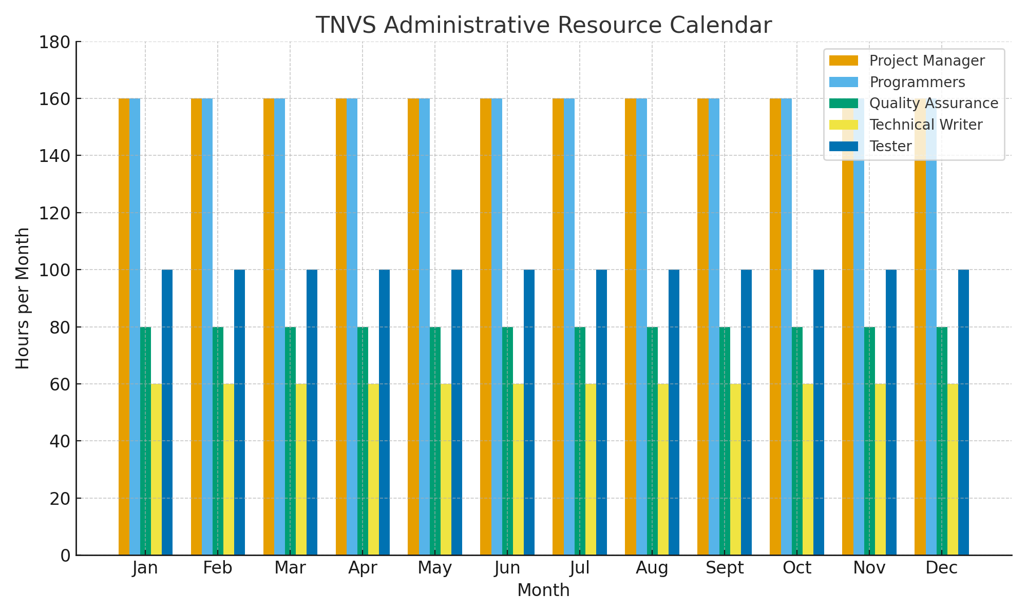

1. **COST BASELINE**

**-** Cost Baseline shows the budget that was estimated to the entire project. It outlines the expected cost for each phase of development and helps our team track expenses throughout the project. This plan serves as a financial guide to make sure the team stays within budget and uses resources wisely.

At the start of the project, most of the expenses were related to research and planning, such as printing materials, internet usage and tools needed for dcocumentation. These costs were minimal but important in helping us organize the project and prepare requirements for the TNVS Administrative Project.

| Project Phase | Budgeted Total (₱) | Comments |
| --- | --- | --- |
| **I. Project Development & Deployment** | **450,000.00** | Initial investment for the development, customization, and deployment of the TNVS Administrative System. |
| **II. Staff Training & Onboarding** | **75,000.00** | Cost for training administrative staff on using the new system, including onboarding materials and training sessions. |
| **Total Estimated Investment** | **525,000.00** | Sum of development and training costs. |
| **Anticipated Savings (Financial Benefit)** |  |  |
| Reduce Staffing Requirements | **-144,000.00** | Reduction in manual paperwork and redundant processes allows for reassignment or reduction of 2 administrative assistants and 1 record clerk. |
| Faster Permit & Compliance Processing | **-80,000.00** | Savings from the annual increase in revenue due to faster processing time (reduced from 3 days to 1 day). |
| Reduce IT Maintenance | **-36,000.00** | Less frequent need for IT troubleshooting and manual updates (reduced from monthly to quarterly). |
| Reduce Printing & Storage Expenses | **-25,000.00** | Digital storage minimizes costs related to paper, ink, and filing space by 70%. |
| **Net Financial Impact (ROI)** | **100,000.00** | The estimated net savings in the first year after accounting for all costs and savings. |

1. **QUALITY BASELINE**

**-** The Quality Baseline sets the standard and expectations that our project must meet to be considered successful. It serves as our guide to ensure that the system we develop meets the required level of performance, reliability, and user satisfaction. By having a clear quality baseline, our team can measure whether the system is functioning properly and providing accurate and secure results.

|  |  |  |
| --- | --- | --- |
| **Item** | **Acceptable Level** | **Comments** |
| System Functionality | Critical/High bug pet major module (e.g,.Reservation, Documents, Legal Management | Measured through regular testing and debugging during development to detect and fix issues early. The system must run smoothly |
| User Interface (UI) | All core administrative tasks (e.g., room reservation, document retrieval) must be completed by a test user | The system design must be simple and easy to understand |
| Data Integrity | 100% of data displayed in the system’s dashboard and reports much match the data stored in the database | Information must always be accurate and consistent, especially for an administrative system. We check if the data displayed is accurate |
| Project Documentation | 100% of required project reports and documents must be proofread, edited, and contain all necessary sections | Ensures that documents are connected. When a document is completed, the team proofread it before moving to the next part |
| Overall Output | Reflects teamwork and effort and is acceptable for final submission | The overall output should reflect the quality standards set by the owner. The team will check if the final outputs meet the project’s requirements |

1. **SPONSOR ACCEPTANCE**

**-**